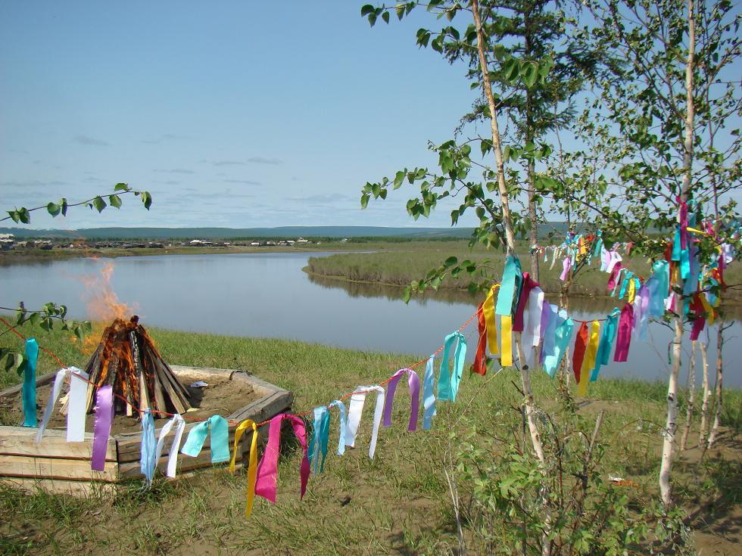
North-Eastern Federal University named after M.K. Ammosov
Ministry of Health, Sakha Republic (Yakutia)
Academy of Science of Republic Sakha (Yakutia)

5th International Scientific Conference

« VILIUISK ENCEPHALOMYELITIS AND OTHER NEURODEGENERATIVE DISEASES: CURRENT ISSUES IN ETIOLOGY AND PATHOGENESIS»

Yakutsk, Sakha Republic, Russia
June, 23-24, 2016

First Announcement

Dear Colleague,

It is our great pleasure to invite you to participate in the 5th International Scientific Conference “VILIUISK ENCEPHALOMYELITIS AND OTHER NEURODEGENERATIVE DISEASES: CURRENT ISSUES IN ETIOLOGY AND PATHOGENESIS”.

Viliuisk encephalomyelitis is a neurological disorder with unknown etiology found exclusively among Sakha people in Siberia. Other burning problems in this population are ALS, spinocerebellar ataxia, spastic paraplegia, myotonic dystrophy, etc. Prevalence of the neurodegenerative disorders, their origin and pathogenesis – are the main subjects of the conference.

The Conference will be held in Yakutsk, Sakha Republic, on 23 -24 June, 2016.
We are pleased to invite you to the celebration of the Sakha national holyday Ysyakh – welcoming summer arrival after a long Yakut winter. Traditional ceremonies and colorful presentations are waiting for you.

With Best Regards, Chairman of the Organizing Committee,
Feodor A. Platonov

REGISTRATION
Please return the registration form to the Organizing Committee at
veconference@mail.ru before May, 20, 2016

ABSTRACTS
Abstracts should be received at the same e-mail address no later than April, 20, 2016, written in English and/or Russian and include 1) the title, 2) author(s) name(s), 3) current affiliation for each author. The length of the abstract is limited to two pages, including tables, images and drawings.

REGISTRATION FEE

Registration fee is $100 per person. It covers:
- access to conference sessions
- access to programme booklet, abstracts
- coffee breaks

The registration fee must be paid to the following bank account.
- :56 INTERMEDIARY: №04410090 WITH DEUTSCHE BANK TRUST COMPANY AMERICAS, NEW YORK, NY, USA S.W.I.F.T.: BKTRUS33
- :57 PAY THRU: JSCB PROMSVYAZBANK, MOSCOW, RUSSIA
- S.W.I.F.T.: PRMSRUMM
- :59 BENEFICIARY: №30109840580000005101
- JSCB «ALMAZERGIENBANK», YAKUTSK, RUSSIA
- :70 DETAILS OF PAYMENT: ACCOUNT №40503840300001000019,
(Federal State Autonomous Educational Institution of Higher Professional Education “North-Eastern Federal University named after M.K. Ammosov”) YAKUTSK, RUSSIA

Please attach proof of payment to the registration form sent to veconference@mail.ru

GENERAL INFORMATION
Yakutsk is located in the North-East of Russia, within about 6-hour flight from Moscow. The weather in June is warm with possible rains, temperatures ranging between 20-30ºC.

CONTACT US
Organizing Committee:
National Medical Center, Bldg C2, Sergelyakhskaya Rd, 677010 Yakutsk, The Russian Federation
Tel (4112) 35-32-75,
Fax (4112) 35-32-75
E-mail: veconference@mail.ru

REGISTRATION FORM
5th International Conference
“VILIUISK ENCEPHALOMYELITIS AND OTHER NEURODEGENERATIVE DISEASES: CURRENT ISSUES IN ETIOLOGY AND PATHOGENESIS”
”.

YAKUTSK, June 23-24, 2016

Family name
Given name
Title
Organization
Address
Job title
Country
Tel. (fax)
E-mail
Form of participation
- Oral report

- Abstract, no report

- Online report

Report title
Hotel accommodations required:
Accompanying person name
Date

